**Title:**

Activity and functional adaptations of isolated halophilic microbiomes revealed through metatranscriptomics

**Authors:**

Gherman Uritskiy, Diego Gelsinger, Adam Munn, James Taylor, and Jocelyne DiRuggiero

**Possible Journals:**

Microbiome, Environmental Microbiology (special deadline Sept 1), Frontiers in Microbiology

**Section 1: Community taxa vary in their contribution to the metatranscriptome**

The endolithic halite microbial communities have been well described in terms of their metagenomic components, in particular their taxonomic distribution. Here, we contrast the taxonomic composition of the halite metagenome with that of the metatranscriptome, as determined by aligning RNA reads to the taxonomically-annotated metagenomic assembly. This comparison headlights core differences between the community taxa abundance (fraction of DNA reads) and overall activity levels (fraction of RNA reads), as the activity of several taxa are over- or under-represented compared to their prevalence in the community. Most strikingly, the total transcriptional activity of Eukaryotes in the community is much higher than their genomic abundance would indicate. Indeed, 12% of non-rRNA metatranscriptomic reads were mapped back to Eukaryotic contigs, compared to only 1% in metagenomic reads. In contrast, Bacteria – particularly Bacteroidetes – represented a smaller fraction community metatranscriptome compared to the metagenome (8% vs 15%). This suggests that the taxonomic composition of the halite microbiomes, which was previously used to assess the relative composition of the community, does not necessarily correspond to its overall functioning. Results from previous DNA-based studies suggested that Cyanobacteria are the predominant carbon fixation group in this community based on relative genome copy numbers estimated from amplicon and whole-metagenomic sequencing. However, our results suggest that Eukaryotes, which are represented by a single halophilic alga, contribute more transcripts to the community than all Cyanobacteria combined.



**Section 2: Algae are highly transcriptionally active**

When interrogating the activity levels of individual contigs, MAGs, and taxa relative to their abundance, we also find significant differences in their activity levels. Panel A shows the average DNA coverage and the average gene activity on individual contigs assembled from the community. Activity levels of contigs belonging to different taxa display drastically different activity levels, which are not necessarily correlated with their abundance levels. In particular, the three phototroph species – two Cyanobacteria and one algae – display similar average gene activity levels despite being present at notably different genomic abundances. Most strikingly, the algae contigs (shown in black) display extremely high levels of transcriptional activity (y-axis), despite being present at very low genome copy counts (x-axis). On the other extreme, Nanohaloarchaea (shown in blue) have very low gene transcription levels given their abundance, suggesting lower overall activity levels. The activity levels of most other taxa are proportional to their abundance, although significant variation is observed within the highly diverse groups of Bacteroidetes and Halobacteria (major class within the Euryarchaeota phylum).

Panel B further quantifies the relationship between abundance and transcription levels in each taxon by computing the expression to abundance ratio (x-axis), while Panel C shows this ratio in individual genomes (MAGs extracted from the metagenomic assembly). It is evident that the Chlorophyta (algae) in the community is orders of magnitude more active than most other taxa in this community. When considering the total number of transcripts contributed (circle diameter), it is clear that algae contribute more to the metatranscriptome than both of the other phototrophs combined. When considering the chromosomal, mitochondrial and chloroplast genomes of the algae separately, we see that the organelle genomes are present in much greater numbers than the main genome (approximately 10X for mitochondria and 20X for chloroplasts). Mamiellophyceae green algae have been characterized to have a single mitochondria and chloroplast, so these coverage differences suggest there are multiple organelle genomes in each organelle, consistent with previous findings in green algae. It is also interesting to note that these organelles are very highly transcriptionally active even considering their genomic abundance, as evidenced by the expression to abundance ratio. The chloroplast genome is also much more abundant and active than the more abundant Cyanobacteria (Halothece), which leads to chloroplasts contributing equal numbers of transcripts to Halothece despite being nearly two orders of magnitude smaller in genome size (95Kbp vs 3,577Kbp).

While Halobacteria (the major taxon within Euryarchaeota) displayed an overall low activity ratio compared to Bacteria and Eukayotes, activity levels of individual MAGs vary greatly. Interestingly, this activity ratio did not correlate with abundance. Indeed, several highly abundant MAGs did not display high activity levels relative to their abundance, while some lowly abundant Halobacteria were highly active.



**Section 3: Organismal relative activity changes between replicates**

Next, we investigated how a given organism’s relative activity levels varied across replicates. When comparing the abundance of contigs to their activity across multiple replicates we can determine how tightly correlated their activity is with their abundance (Panel A). When looking at the Pearson coefficients of this relationship in all longer (5kb+) contigs, we find that the majority of contigs do not display significant correlation (Panel B). To get more robust estimates of this correlation we also compared the abundance activity levels of entire MAGs across the 12 replicates. Similar to the contigs, we found that even in near complete genomes the abundances did not necessarily correlate with activity (Panel C and heatmap) with the majority of the MAGs not correlating in terms of their activity abundance.

This means that for most organisms, their activity levels change from sample to sample, likely depending on how favorable the conditions are in each individual halite. These conditions may vary between halites because of different physical conditions, community environment, or specific inter-species interactions that may influence their transcriptomes. Another possible explanation that the relative fraction of active cells in relation to dormant or dead cells varies between nodules. Taken together with the previous result showing differences in activity levels between different taxa, this adds a layer of complexity to the activity variance in the halite communities. Not only do different taxa have different relative contribution rates to the metatranscriptome, but even in individual taxa there are major differences in their activity from sample to sample. This highlights the importance of interrogating the taxonomic components of such communities through RNA sequencing, as metagenomic sequencing would fail to capture this diversity.



**Section 4: Major highly expressed functional pathways across taxa**

To investigate the relationship between the metagenome and metatranscriptome at a functional level, we compared the relative activity of various functional pathways (KEGG Brite hierarchy). The abundance of each gene in the DNA samples was estimated from the DNA coverage of the contig that it lies on, expressed in copies-per-million reads (CPM), while the expression of the genes was expressed as transcripts-per-million reads (TPM). The total abundance (CPM) and activity (TPM) of pathways were estimated by combining abundances and activity of the genes that constituted each pathway. By standardizing each DNA and RNA library to the same total CPM or TPM and then standardizing to the maximum value (abundance or expression) in each pathway, we were able to compare the relative expression of each pathway in relation to its abundance in the metagenome.

As observed in a previous study of this community’s functional potential, the relative prevalence of pathways remained stable between replicates despite notable variation in fine-scale taxonomic composition. Transcriptionally, however, multiple pathways were found to have higher or lower expression than expected from the functional potential. Not surprisingly, we found that across all domains of life in this community, oxidative phosphorylation and translation were consistently some of the most active pathways. Despite differences in phylogeny and functional potentials, Archaea and Bacteria shared many other highly expressed pathways, including DNA transcription, protein folding and maintenance, Nitrogen metabolism, and C5-branched dibasic metabolism. In both the phototrophs – Cyanobacteria and Chlorophyta – the photosynthetic pathway was the most active pathway across all the replicates.



**Section 5: The functional profile is more variable than the functional potential**

Comparing the pathway expression profiles in relation to their abundance in the metagenomes also revealed that pathway expression is more variable compared to their abundances, as evidenced by the longer branch length on the sample clustering dendrogram. To further investigate this phenomenon, we standardized the abundance or expression values of each pathway across the replicates to range from 0 to 1, and computed their variance. The resulting data allows us to compare the variance in pathway abundance to the variance in pathway expression in the whole community or a taxon of interest. We found that across all tested taxa, the variance in pathway functional potential significantly lower than the variance in functional expression. This suggests that while the overall commercial potential of these communities remain stable between replicates, which is consistent with previous findings, their activity changes significantly in individual halites. This variation is likely driven by differences in conditions inside different halites.

While it was not tangible to measure the physical conditions within each single halite, it can be inferred that the different sizes and topologies of the nodules may have influenced relative humidity and temperature. Alternatively, topology differences could lead to varying conditions at different location within a given nodule, leading to varying metatranscriptomic results depending on which halite pocket was sampled. Another explanation is that the unique microbial consortia found in each halite could lead to unique transcriptional adaptations in the community members. Competition and symbiotic interactions between neighboring cells could alter their transcriptional activity, as they adjust to the unique taxonomic environment in each nodule. Finally, the variation of transcriptional activity could come from the metatranscriptome being in a constant state of flux, where the expression of pathways is constantly changing as a function of the previous state, current conditions, and a degree of randomness. If these communities displayed a wide range of short-term transcriptional variation, our limited sampling methods could produce the observed variance.

Regardless of the reason(s), it is evident from this data that halite microbial communities undergo transcriptional adaptations to fit the unique conditions in different nodules, while the functional potential remains consistent. This likely stems from the rapidly changing conditions in the nodules – particularly humidity – which requires the microbial community metagenome to be “prepared” for a range of conditions but produce unique transcriptional responses to best suit the current conditions.



**Section 7: Characterization of putative genome of novel Dolichomastix genome**

Given the high importance of *Dolichomastix* alga for community carbon fixation, we further characterized its genome in relation to its closest sequenced phylogenetic relatives *Ostreococcus tauri* and *Micromonas pusilla*, and another halophilic algae *Dunaliella salina*. Through a combination of assembly and binning methods we reconstructed the alga chromosomal, chloroplast, and mitochondria draft genomes. The main genome was 10.3Mbp long, compared to 13.1Mbp in *O. tauri*, 22.4Mbp in *M. pusilla*, and 343.7Mbp in *D. salina*. All four genomes were functionally annotated and the isoelectric point (pI) or each gene was estimated. The differences in predicted pI distributions of the genomes revealed potential differences in intra-cellular environment. We found that the pI distribution of the *Dolichomastix* halite alga is relatively similar to its closest relatives *Micromonas* and *Ostereococcus*. However, the non-halophilic relatives of the halite algae displayed a trimodal pI distribution curve, with a notable fraction of the genes predicted to have a pI of greater than pH 10.5. Dolichomastix on the other hand, lacked this third peak, similar to a distant but halophilic algae *D. salina*. Of the few proteins in Dolichomastix that were still predicted to be highly alkaline (pI<11), the majority were histone and DNA-associated proteins, which need to be alkaline to maintain function.

To investigate whether the genes in the alkaline peaks of *Micromonas* and *Ostereococcus* were still present in Dolichomastix, we aligned the amino acid sequences of the *Micromonas* and *Dolichomastix* genomes. Of the 105 alkaline genes in *Micromonas* that were found to have homologues in Dolichomastix, 80 had significantly acidified profiles in the *Dolichomastix* homologue. These acidified proteins did not belong to any specific functional pathway or cellular compartment, but many were chaperones, mRNA processing proteins, and DNA-binding proteins. These results suggest that the proteome of halophilic algae such as the halite *Dolichomastix* are under significant selective pressure to not have a high pI, likely because of a different cytoplasmic and/or nuclear environments.

To further compare the halotolerant *Dunaliella* and *Dolichomastix* genomes, we found homologs of important high-salt adaptations proteins. Genes coding for 51 cellular and 46 membrane-bound proteins previously identified in *Dunaliella* with proteomics following salt-stress were aligned against the *Dolichomastix* genes to find 33 homologous genes that could play a role in the high-salt tolerance. Of these, all the genes were actively expressed in *Dolichomastix*, and a significant majority were highly expressed. This suggests that *Dunaliella* and *Dolichomastix* may share similarities in their adaptations to high salinity. *Dunaliella* has been characterized to upregulate major metabolic pathways to produce enough energy to actively combat high external salt concentrations. Similarly, *Dolichomastix* is observed to have extremely high rates of photosynthesis and oxidative phosphorylation, likely undergoing a similar strategy of using active transport to maintain correct internal salt conditions while producing secondary metabolites to counter-act external osmotic pressure.



**Section 6: Dolichomastix alga is the major contributor to photosynthetic transcripts**

As shown previously, we found that the sole alga in the community contributes significantly to the metatranscriptome, producing more RNA transcripts that both the Cyanobacteria taxa combined. However, we wanted to further compare the relative contributions of the phototrophs to the functioning of the community in terms of carbon fixation, particularly because the algae’s chloroplast was shown to be more numerous (in terms of genome copies) and active than even the most abundant Cyanobacteria. We identified several key genes from the photosynthetic pathway that were annotated and present in all three phototrophs found in this community – Dolichomastix (the alga), Halothece, and Euhalothece (the Cyanobacteria). In almost every single photosynthetic gene, the algae contributed an order of magnitude more transcripts than both of Cyanobacteria combined. These results suggest that not only is the alga disproportionately active given their low abundance in the samples, but also that it is the major contributor of photosynthetic transcripts. If the photosynthetic gene transcriptional levels are assumed to be proxies to photosynthetic activity, it can be inferred that algae are the major primary producers of this community. These results are unexpected given the previous characterization of halite microbiomes with 16S rRNA gene and shotgun metagenomic sequencing, given the high relative abundances of Cyanobacteria compared to Chlorophyta.



**Section 8: Virus transcriptional activity does not correlate with abundance**

To further investigate the transcriptional differences across different samples we looked at the viral components of this community. Using protein sequence homology, we extracted 91 viral contigs ranging in size from 5Kbp to 50Kbp. Viral transcription activity implies that the virus is undergoing active infection of a host cell, which suggests that the activity of a given virus in a sample is dependent not only on its abundance, but on its infective success. Consistent with this, we found that a virus’s abundance does not effectively predict its activity levels. In a given sample, many active viral contigs were not highly abundant, and highly-abundance contigs were not necessarily active. Indeed, computing the Pearson correlation of viral abundance to viral transcriptional activity revealed that only 12 out of the 91 viruses showed significant positive correlation. It is likely that these highly correlating viruses are likely integrated in their host’s genome and thus maintain constant base-level transcription.

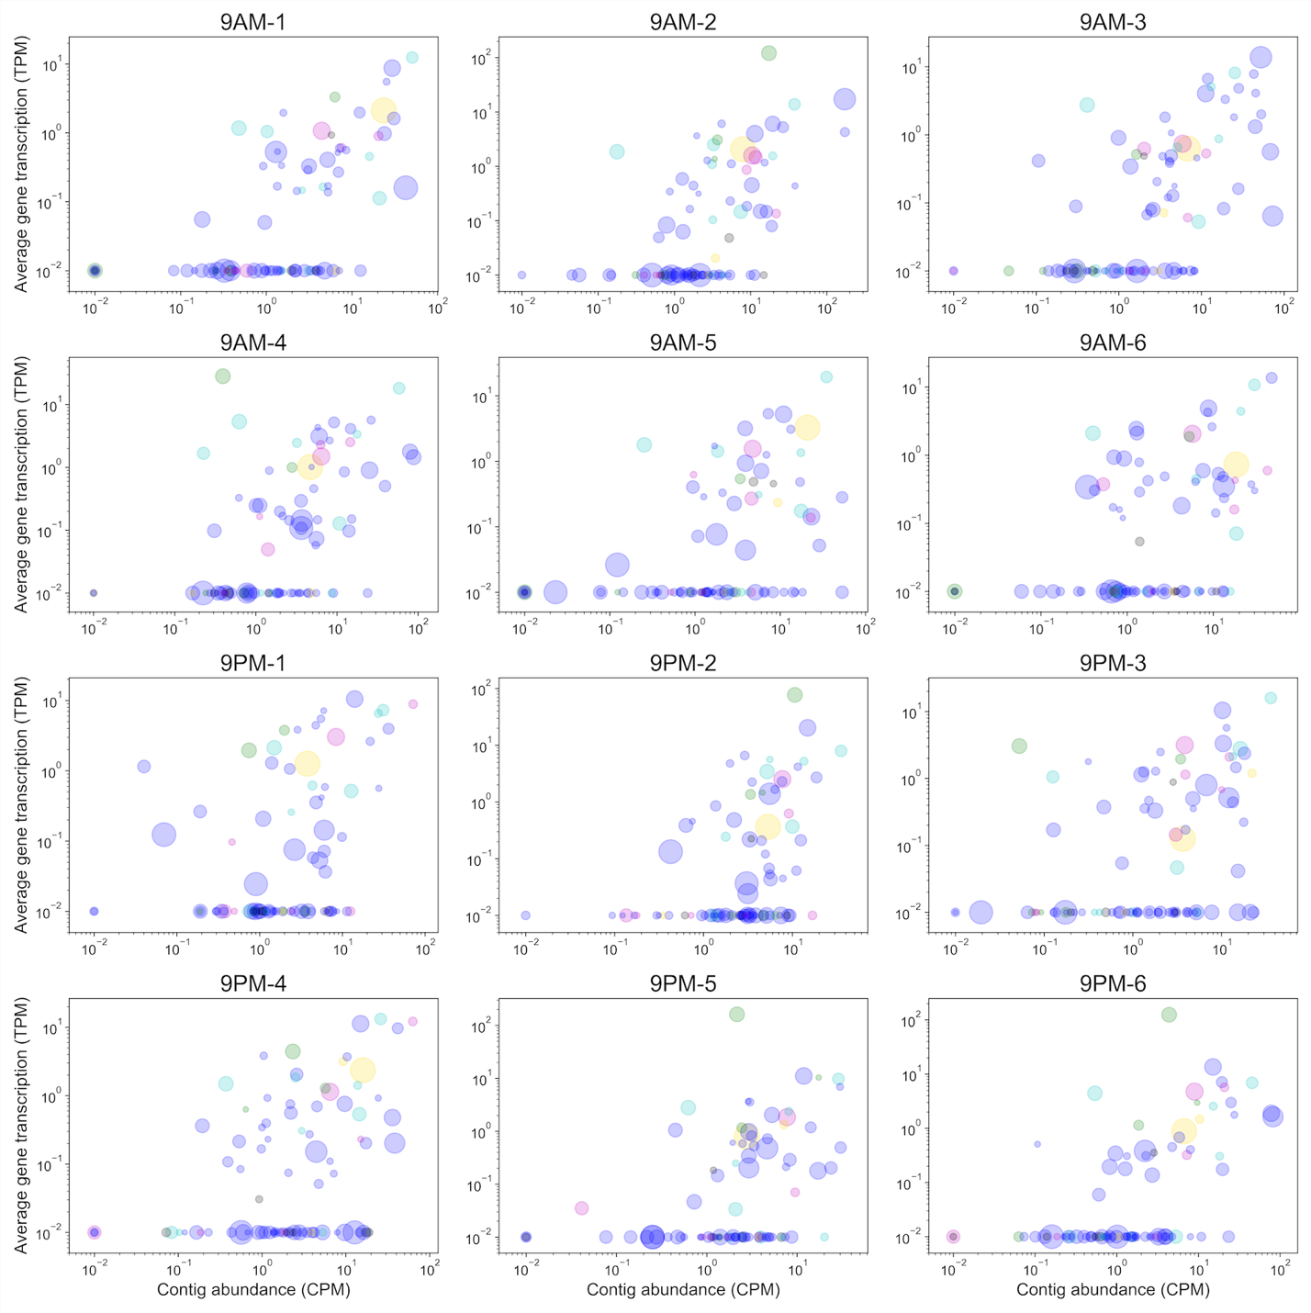



**Discussion:**

The results of investigating the RNA component of this endolithic community revealed much about its transcriptional activity and community function. While previous studies have characterized the halite communities based on its genomic components, we found that the taxonomic composition and functional potential of the community metagenome did not provide complete information for inferring community function. Previous shotgun metagenomic profiling predicted a robust and reproducible functional potential landscape, however out new metatranscriptomic analysis revealed that the community functional activity varies significantly between replicates. These results imply that the conditions within individual halite can vary. While the halite community pan-genome is primed to survive in a range of conditions, the community transcriptome adjusts to the unique conditions found in each halite at any given point in time, resulting in transcriptional variation between our replicates. Additionally, out observations of varying activity levels of individual organisms suggest that organisms may be more or less dormant depending on the unique factors found in each halite nodule. Alternatively, the discordance of the genomic and transcriptomic components could also result from varying fractions of “relic” DNA coming from dead cells, with the living cells maintaining a constant total transcriptional activity.

The varied transcriptional profiles of individual halites likely stem from a combination varying rock topology, humidity and temperature metrics, inter-cellular interactions, and stochastic factors. Previously, water has been described as the major driving factor of the taxonomic diversity in this desiccated environment. It is likely that water availability also has major implications for this the transcriptional adaptations of its communities. In particular, it is likely that internal humidity can vary significantly from nodule to nodule depending on their capacity for water retention, which in turn could depend on structural characteristics such as size, degree of porousness, and shape. These changes in water availability are transient, as the halite nodules “recharge” after every high-humidity night through deliquescence, which forces the microbial communities to maintain relatively similar functional potentials to be able to thrive in any condition, to which they then adapt transcriptionally. The inter-cellular interactions also likely vary between nodules, as each halite possesses a unique ensemble of taxa. These differences could translate into community-specific transcriptional adaptations are different organisms rely on each other to produce metabolites precursors. Such interactions are particularly important when considering the different phototrophs presents in the halite communities, as they are the only organisms that fix organic carbon for the rest of the community. Because each halite has a different abundance combination of Dolichimastix, Halothece, and Euhalothece, the nodule’s heterotrophs likely need to adjust transcriptionally to the abundance and nature of available metabolites. These composition differences also likely influence the effective viral infections occurring in any given halite. Finally, the transcriptional differences could at least partially stem from stochastic short-term variation in gene expression. In other words, it is possible that two identical communities under the same conditions could also have unique metatranscriptomes. In conclusion, due to practical limitations and compounding factors were unable to link the observed variance to any particular factor affecting the differences. However, our observations of transcriptional variance are likely explained by a combination of variable described above.

Our results emphasize that sequencing the genomic component of a microbial community is not sufficient to understand the true functioning of a population, particularly in terms of sample variance. Indeed, previous studies have been unable to detect notable differences in functional potential between individual nodules, however this study found significant variation in the transcriptional landscapes of microbial communities residing in halites from the same area.

Our study also highlighted the importance of a newly identified Dolichomastix alga, which has previously received little attention compared to the more numerous Halothece Cyanobacteria. The extremely high transcriptional activity levels of this alga, particularly its chloroplasts and mitochondria, were highly unexpected. Not only does the alga have an active transcriptional profile in relation to its low genomic abundance, but it contributes the vast majority of transcripts for the photosynthetic pathway in the entire community, which shifts the previously-established Cyanobacteria-centric understanding of halite microbiome functioning.

The newly extracted putative genome of the Dolichomastix alga displayed similar high-salt adaptation features to a phylogenetically distant Dunaliella – another halotolerant alga. Compared to its closest relatives that have been sequenced – Micromonas and Ostereococcus – the halite Dolichomastix predicted proteome appears to lack highly alkaline proteins, an adaptation similar to that of Dunaliella. We postulate that this adaptation is indicative of a unique cytoplasmic environment optimized for combating high extra-cellular salt concentrations.

Our analysis also attempted to compare the community and individual taxa transcriptional adaptations between time points. Samples were collected in light and humid conditions (9am) and in dark and dry conditions (9pm). However, we found no significant difference in overall metatranscriptomic landscape and were unable to find statistically significant differentially expressed genes or pathways when considering false discovery rates. Instead, we found there to be a lot of background noise in the expression profiles of individual replicates, which likely concealed any real differential expression. The high noise levels likely stem from the aforementioned high inter-replicate variation in conditions and metatranscriptomic landscape. In other words, we found a greater variation between replicates there between the two tested time-point conditions. These results are seemingly in conflict with previous work, which uncovered differences in Chlorophyll activity throughout the dial cycle. However, this study directly measured the Chlorophyll abundance (and possible activity) through absorbance spectra, which could be influenced by post-transcriptional regulation of the photosynthetic pathways.

**Brief conclusions:**

1. We describe the transcriptional functioning of the halite microbiome for the first time, identifying important active pathways for each major taxon.
2. We show that some taxa contribute more or less than others to the community metatranscriptome. Algae appear to be the major primary producers of this system.
3. Segregated halite communities are highly varied transcriptionally in terms of taxa total activity, total pathway activity, and viral activity, despite being relatively similar in terms of metagenomic composition.
4. Community functional description
   1. Which paths are important to this community in relation to the metagenome
   2. What are the functional adaptation differences between he phototrophs, salt-in, salt-out, phyla
   3. Which organisms are important in relation to the metagenome
   4. What’s so special about this alga
      1. Genome
      2. Photosynthesis
      3. Salt adaptations
5. Heterogeneity of nodules
   1. Transition by talking about attempted measurements in dial cycle adaptations
   2. Organism relative activity changes between nodules
   3. Pathway metatranscriptome is more diverse than metagenome
   4. Virus activity does not correlate with abundance